**REPORT**

**SCREEENING (PEER REVIEW OF ‘SHEE’)**

**13th JUNE 2024**

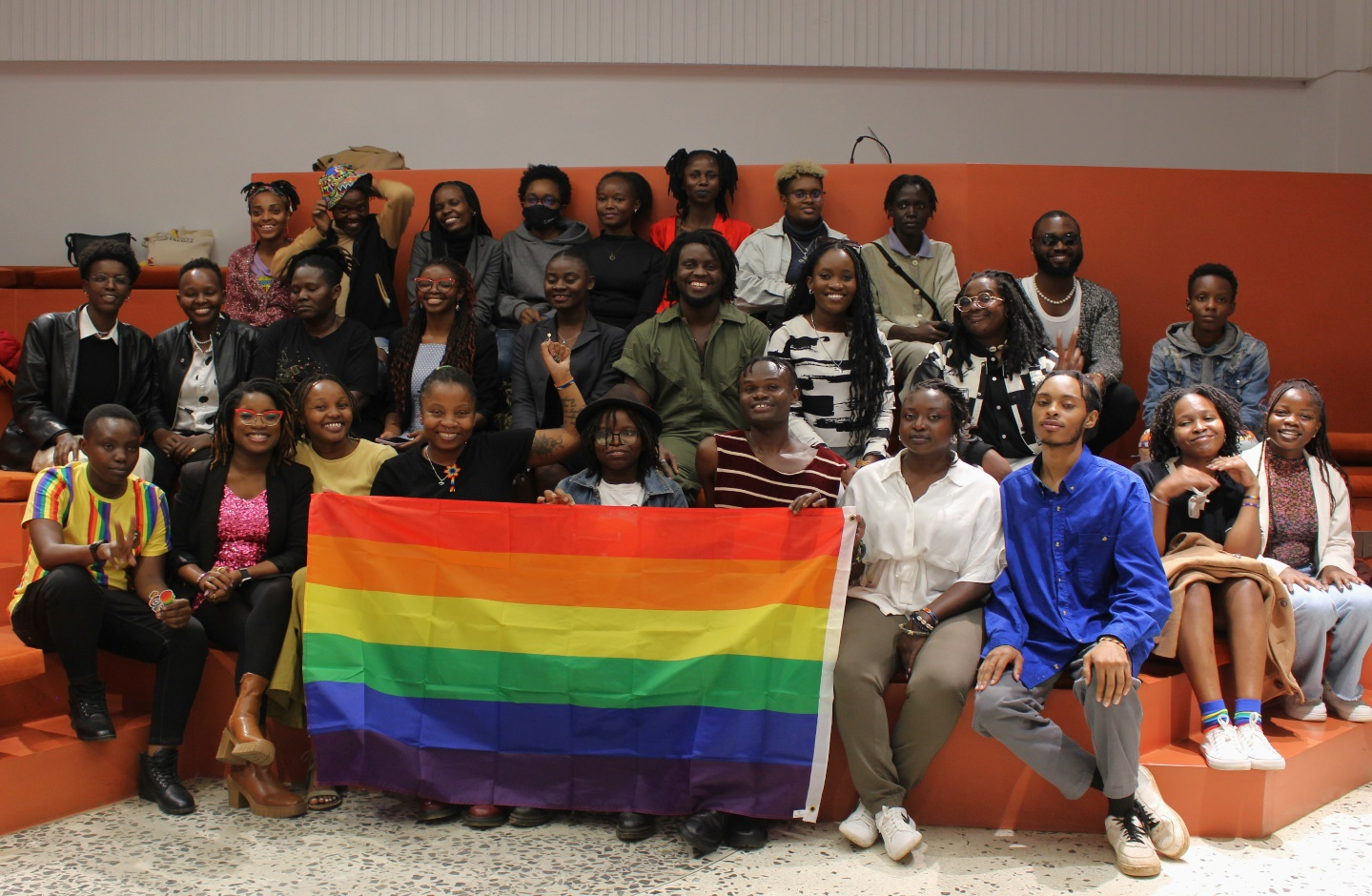

Pride Month, celebrated every June, commemorates the Stonewall Riots of June 1969 in New York City, a pivotal event in the LGBTQI+ rights movement. The riots, sparked by a police raid on the Stonewall Inn, led to widespread protests and the formation of advocacy groups. The first Pride marches in June 1970 marked the anniversary of these riots. Today, Pride Month celebrates LGBTQI+ culture and progress, advocating for continued equality through parades, festivals, and various events.

Across the African continent, with 54 countries, LGBTQI+ persons face severe criminalization and constant threats due to anti-discriminatory laws. In Kenya, sodomy laws persist, criminalizing queer identities and excluding them from social welfare, healthcare, security, and workplace protections. This ban on an integral part of society highlights a deep yearning for safe spaces where LGBTQI+ persons can freely express themselves, even if just for a moment, without the shadow of these discriminatory bans.

A significant milestone was achieved at the International Planned Parenthood Federation (IPPF) African region as it held its first Pride event at the Nairobi office, draped in all the colors of the rainbow. This event brought together over 30 LGBTQI+ individuals and allies in Kenya. Organized in collaboration with the Feminist Opportunity Now (FON) Project and IPPF's member association in Kenya, the Reproductive Health Network Kenya (RHNK), the celebration marked a historic moment of solidarity and visibility for the LGBTQI+ community.

The event began at 6:30 PM and was formally opened by Wanjiru Wairimu, the Program Officer for Kenya and Ethiopia for the FON project. She warmly welcomed the participants into the safe cocoon that IPPF had created for the celebration. Following her, Benedicta Oyedayo, the Community Engagement and Partnership Lead at IPPF African Region, extended her welcome to the participants. She provided a quick housekeeping overview, including a safety and security briefing for the day, and officially declared the event open!

Scar, known for poetry that connects people by reflecting her own experiences and those around her, acting as a mirror for others to see themselves and understand our shared human experience, delivered a soul-gripping and resonant slam poetry performance that profoundly captivated the audience. It explored the intersection of faith and sexuality, the existence of LGBTQI+ persons under discriminatory laws and policies, and the arbitrary openness to heartbreak and the impossibility of envisioning a future. The poet highlighted how, in many queer African contexts, the heteronormative standards that equate marriage with authenticity still dominate, leaving queer relationships as flowers waiting to blossom. In Kenya, this remains a distant achievement.

The performance also explored queer love in its wholesomeness and intensity, illustrating how society and hate often snatch this love away from LGBTQI+ Africans, emphasizing its fleeting nature. A poignant piece titled "Dear Straight People" humorously opened with, "Dear straight people, stop telling me you cannot imagine two people of the same sex having sex. Guess what? No one has asked you." This comical yet powerful poem expanded on the roles of active bystanders and allies in ensuring freedom and equality for LGBTQI+ persons. The poet also delivered a solidarity piece addressing the war in Congo, calling for collective action and underscoring that no one is free until all of us are free.

The standout moment of the event was the screening of "Shee," a 12-minute film that captivated the audience with its powerful portrayal. The room fell into a profound silence as LGBTQI+ Kenyans watched their own story unfold on screen, depicting the legal, social, and economic hurdles they face. Despite these challenges, the film underscores their ongoing struggle for recognition, equality, and the freedom to live authentically and without fear.

After a break, participants reconvened at the amphitheatre for what was initially planned as a 30-minute discussion on "Shee," but extended into a captivating two-hour dialogue among the panellists: AdudaHera, the writer of the film and a prominent Kenyan writer, director, and producer based in Nairobi known for her LGBTQIA+ advocacy; Linda Njiru, Campaigns Manager for Africa at All Out, a dedicated advocate for global LGBT+ rights; Marylize, a human rights activist and expert in communications and gender focusing on LGBTIQ+ and women's rights globally; and Mathendu Muchoki, a Nairobi-based filmmaker, writer, and actor recognized for his LGBTQ+ activism and bold storytelling.

The discussion centered on the movie's themes and their connection to the Sexual Reproductive Health and Rights (SRHR) realities of LGBTQI+ Kenyans. It highlighted how the themes of trust, choice, and communication in "Shee" resonated deeply within Kenya's challenging legal and social environment, illustrating the universal struggles of navigating relationships and identity under discriminatory laws. Panellists addressed specific challenges queer individuals face in accessing SRHR services, including stigma and inadequate provider training.

Efforts to overcome legal and financial barriers to parenthood for LGBTQIA+ couples were emphasized, with a strong call for advocacy and policy changes to ensure legal recognition of LGBTQIA+ families and improved access to assisted reproductive technologies. The panel underscored the crucial role of representation in media, exemplified by "Shee," in shaping societal attitudes toward LGBTQIA+ relationships in conservative societies like Kenya, fostering empathy, challenging stereotypes, and advocating for equality.

Moreover, the discussion highlighted the obstacles filmmakers in Kenya encounter when exploring LGBTQIA+ themes, such as funding constraints, censorship, limited distribution channels, and societal resistance. Despite these challenges, there was a collective call to prioritize and amplify narratives of queer joy in storytelling to counter stereotypes and celebrate the diversity of LGBTQIA+ experiences.

The session was then opened for questions and comments from the participants, many of whom offered valuable contributions. They expressed concerns about the socio-political and economic situation for queer Kenyans and how societal norms and practices impact their sexual reproductive health-seeking behavior. Participants also emphasized the need for safe spaces, like the one created by IPPF ARO, to convene and discuss pivotal issues affecting the community while reflecting on ways forward.

A significant part of the discussion focused on integrating comprehensive sexuality education through a human-rights perspective, engaging traditional and religious leaders, and healthcare service providers. This approach should also be reflected in resourcing responses to LGBTQI+ sexual reproductive health needs.

The screening concluded successfully, with participants providing valuable feedback. They expressed a desire for extended time for conversations and engagement, applauded the thorough organization and thoughtful setting provided by IPPF ARO, and voiced a strong interest in more communal organizing events in the future. This positive reception highlights the importance of creating spaces for open dialogue and community building within marginalized groups.